POP3 Server

📥 What is a POP3 Server?
# Source: AI Source: Provided by: [Data Path: Persons Table -> ID Column: 1, Name_En Column: Motasem Essam] -> From: [ChatGPT] on [1/21/2026]
A POP3 server is a mail server that lets you receive emails using the Post Office Protocol version 3 (POP3).
📬 It downloads emails from your inbox to your local device — then (usually) deletes them from the server.

🔍 In Simple Terms:
# Source: AI Source: Provided by: [Data Path: Persons Table -> ID Column: 1, Name_En Column: Motasem Essam] -> From: [ChatGPT] on [1/21/2026]
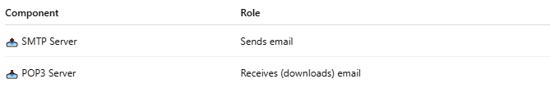

Component | Role
📤 SMTP Server | Sends email
📥 POP3 Server | Receives (downloads) email

📡 How It Works:
# Source: AI Source: Provided by: [Data Path: Persons Table -> ID Column: 1, Name_En Column: Motasem Essam] -> From: [ChatGPT] on [1/21/2026]
- Your email app (e.g., Outlook, Thunderbird, PHPMailer with POP) connects to the POP3 server.
- POP3 authenticates using your email + password.
- It downloads emails from your inbox.
- Optionally deletes them from the server after download.

✅ Example POP3 Server Settings
# Source: AI Source: Provided by: [Data Path: Persons Table -> ID Column: 1, Name_En Column: Motasem Essam] -> From: [ChatGPT] on [1/21/2026]
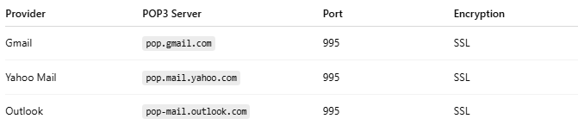

Provider | POP3 Server | Port | Encryption
Gmail | pop.gmail.com | 995 | SSL
Yahoo Mail | pop.mail.yahoo.com | 995 | SSL
Outlook | pop-mail.outlook.com | 995 | SSL

⚠️ POP3 vs IMAP
# Source: AI Source: Provided by: [Data Path: Persons Table -> ID Column: 1, Name_En Column: Motasem Essam] -> From: [ChatGPT] on [1/21/2026]
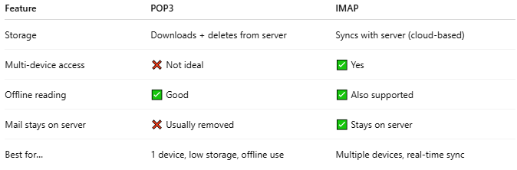

Feature | POP3 | IMAP
Storage | Downloads + deletes from server | Syncs with server (cloud-based)
Multi-device access | ❌ Not ideal | ✅ Yes
Offline reading | ✅ Good | ✅ Also supported
Mail stays on server | ❌ Usually removed | ✅ Stays on server
Best for… | 1 device, low storage, offline use | Multiple devices, real-time sync

📌 Typical POP3 Usage
# Source: AI Source: Provided by: [Data Path: Persons Table -> ID Column: 1, Name_En Column: Motasem Essam] -> From: [ChatGPT] on [1/21/2026]
- Old-school desktop clients that download mail once and store locally
- Use when internet is limited, or storage is needed offline
- Now mostly replaced by IMAP for modern apps

✅ Summary
# Source: AI Source: Provided by: [Data Path: Persons Table -> ID Column: 1, Name_En Column: Motasem Essam] -> From: [ChatGPT] on [1/21/2026]


Term | Role
SMTP | Sends mail out
POP3 | Downloads (and usually deletes) mail
IMAP | Syncs mail with server in real time

